**EXPERIMENT- 4**

## Aim: Realization of logic functions with the help of universal gates NAND and NOR Gate

**PRE TEST**

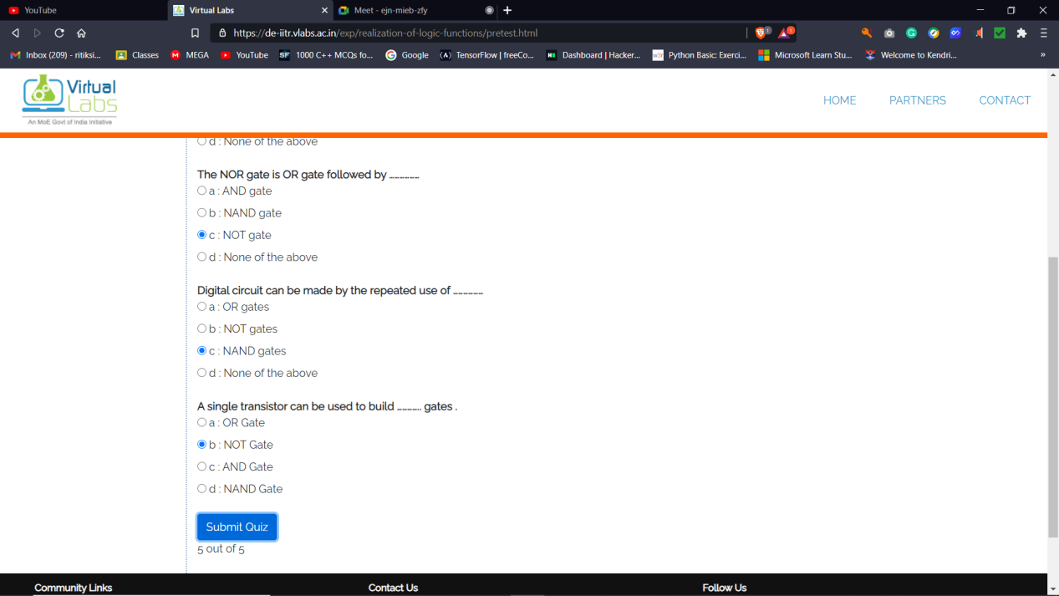

**POST TEST**

